Project Design Phase-II
Technology Stack (Architecture & Stack)

Date | 28 June 2026
Team ID
Project Name | ShopEZ-E-Commerce Application.
Maximum Marks | 4 Marks

ShopEZ Technical Architecture: 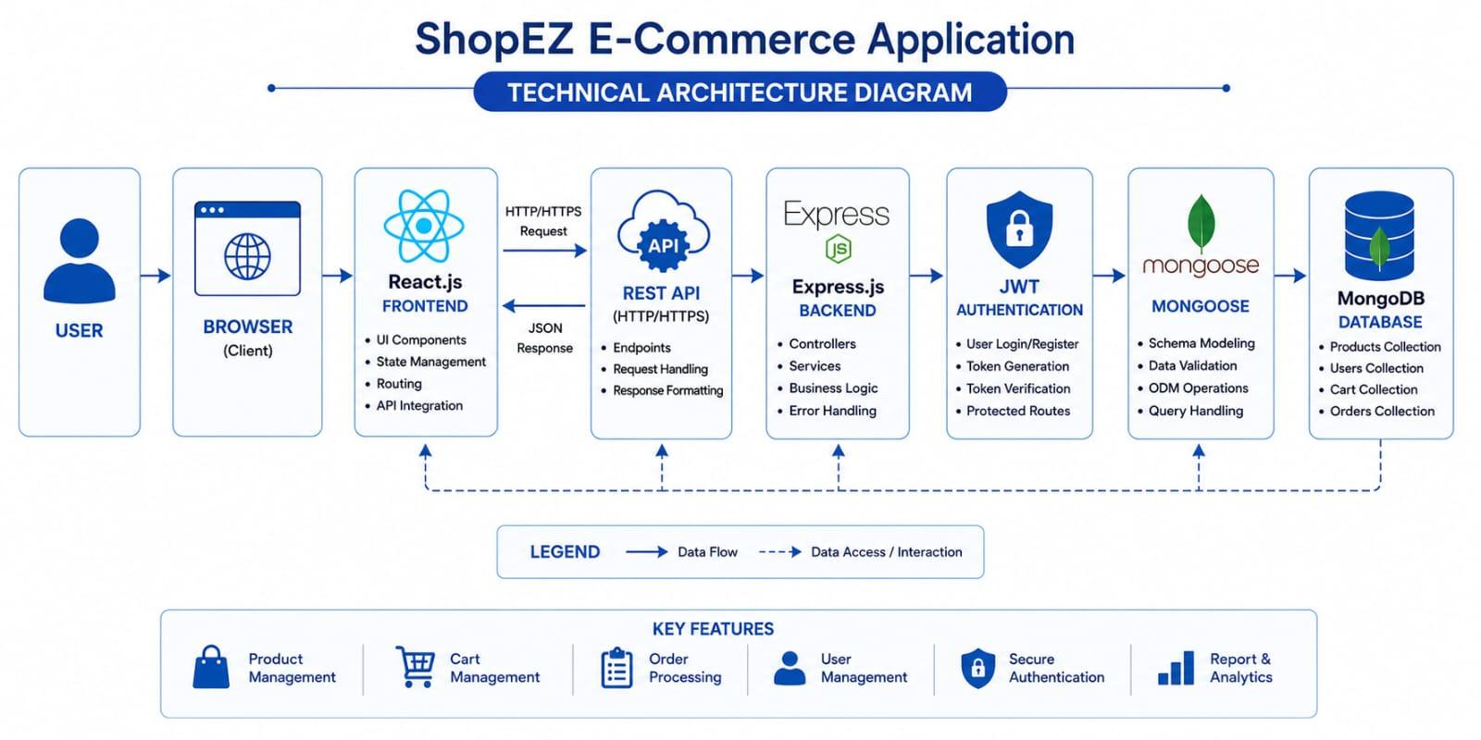

Table-1 : Components & Technologies:
S.No | Component | Description | Technology
1. | User Interface | Web interface for users to register, log in, browse products, manage the shopping cart, and place orders. | React.js, Vite, HTML5, CSS3, JavaScript, Bootstrap
 | Application Logic-1 | Handles user registration, login, authentication, and authorization. | Node.js, Express.js, JWT, bcrypt
 | Application Logic-2 | Handles product listing, shopping cart management, and order processing. | Node.js, Express.js
 | Application Logic-3 | Handles database communication, CRUD operations, request processing, and response management between the application and MongoDB. | Mongoose ODM, MongoDB
 | Database | Stores user accounts, product details, shopping cart, and order information. | MongoDB
 | Cloud Database | Cloud database is not used in the current version of the project. | Not Applicable (N/A)
 | File Storage | Stores project files and product images in the local file system. | Local File System
 | External API-1 | No external APIs are integrated in the current version. | Not Applicable (N/A)
 | External API-2 | No additional external APIs are used in the project. | Not Applicable (N/A)
 | Machine Learning Model | Machine learning functionality is not implemented in this version. | Not Applicable (N/A)
 | Infrastructure (Server / Cloud) | The application is deployed on a local development server. The frontend runs using the Vite development server, while the backend runs on the Node.js and Express.js server. | Local Server (Node.js + Express.js + Vite)

Table-2: Application Characteristics:
S.No | Characteristics | Description | Technology
1. | Open-Source Frameworks | The application is developed using open-source frameworks that support frontend development, backend services, and database connectivity. | React.js, Vite, Node.js, Express.js, MongoDB, Mongoose, Bootstrap
 | Security Implementations | The application implements secure user authentication using JWT, encrypts passwords with bcrypt, validates user input, and protects routes from unauthorized access. | JWT Authentication, bcrypt, Express Middleware
 | Scalable Architecture | The MERN stack architecture follows a modular design, allowing the application to be extended with additional features such as online payments, wishlist, product reviews, and order tracking in future releases. | React.js, Node.js, Express.js, MongoDB
 | Availability | The application is available through the local development server during development and can be deployed to cloud platforms for continuous availability in future. | Local Server (Node.js, Express.js, Vite)
 | Performance | The application provides fast page loading, efficient API communication, and optimized database operations to ensure smooth user experience. | Vite, Express.js, MongoDB, Mongoose

